* Explain the Role of DHCP
* Configure and verify DHCP Client and Relay

**DHCP (Dynamic Host Configuration Protocol):**

* DHCP is an abbreviation for Dynamic Host Configuration Protocol.
* Cisco IOS features known as Easy IP Lease which is full-featured DHCP server.
* DHCP is a client server protocol that automatically provides an IP to hosts.
* DHCP also provide IP, subnet mask, default gateway, DNS server & other config.
* DHCP allows a network device to dynamically receive IP address parameters.
* DHCP process follows DORA process, Discover, Offer, Request & Acknowledgement.
* DHCP is app layer protocol used by hosts for obtaining network setup information.
* DHCP Server dynamically configures a host or Network device in a network.
* DHCP is Client server protocol, which uses User Datagram Protocol services.
* DHCP port number for server is UDP port 67 and for the client is UDP port 68.
* DHCP assigned Internet Protocol (IP) address from a pool (range) of addresses.
* Dynamic Host Configuration Protocol (DHCP) is an application layer protocol.

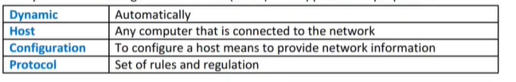

**Advantages of DHCP:**

* Primary advantage of DHCP is easier management of IP addresses.
* Centralized network client configuration.
* DHCP greatly reduce the time required to configure & reconfigure computers.
* DHCP Server assigning IP addresses automatically avoid configuration errors.
* Ease of adding new clients to a network.
* Reuse of IP addresses reducing the total number of IP addresses.
* No need to reconfigure each client separately.
* Configure the network from a centralized area.
* Easy handling of new users and reuse of IP address can be achieved.

**IOS DHCP Server:**

* Cisco devices running Cisco software include DHCP server.
* Cisco router can be used as a DHCP server and the various options available.
* Cisco IOS routers and layer 3 switches can be configured as DHCP server.
* The Cisco IOS DHCP server is a full DHCP server implementation.
* Cisco IOS DHCP assigns and manages IP addresses from specified address pools.
* Cisco IOS DHCP server can be configured to assign additional parameters as well.
* DHCP server is the one responsible for handing out IPs to the clients.

**DHCP Client:**

* DHCP client is a host using DHCP to obtain configuration parameters.
* The endpoint that receives configuration information from a DHCP server.
* DHCP client is anything needing an IP address that is not configured as a static.
* Cisco routers can be configure as both DHCP servers and DHCP clients.
* DHCP clients use UDP broadcasts to send their initial DHCPDISCOVER messages.
* DHCP Client uses UDP port 67 to send messages to the server.

**DHCP Relay:**

* DHCP relay agent is any host that forwards DHCP packets between clients and servers.
* DHCP Relay allows clients to obtain DHCP info from a server on a different subnet.
* Relay agents are used to forward requests and replies between clients and servers.
* Relay agents are used to forward request when they are not on the same physical subnet.
* The devices that do the forwarding are referred to as DHCP relay agents.
* Relay agents forward packets differently than normal IP forwarding.
* Relay agents receive a DHCP message & generate a new message out another interface.
* DHCP relay agent adds a GIADDR (Gateway Address of Packet) field.
* DHCP relay also add the Relay agent information option 82 if enabled.

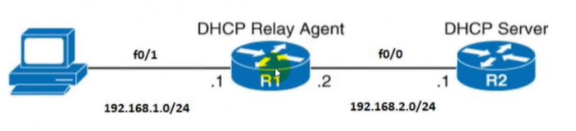

**DHCP Operation:**

* DHCP important messages exchanged between a DHCP client & DHCP Server.
* Four basic phases are required in DHCP operations between a DHCP server and DHCP client.
* DHCP operation process for IPv4 called **DORA** process.

**DHCP Discover Message:**

* First message generated in the communication process between server and client.
* Client host generated this message to discover DHCP server in a network.
* This message is broadcasted to all devices present in a network to find DHCP server.
* In case no respond from a DHCP server, windows client assigns itself, an APIPA.
* DHCP Discover message use broadcast IP address and broadcast MAC address.
* This message is 342 or 576 bytes long & Destination MAC address is FFFFFFFFFFFF.
* Source IP address is 0.0.0.0 because DHCP client has no IP address until now.
* Destination IP address is broadcast 255.255.255.255.

**DHCP Offer Message:**

* DHCP servers receive a DHCP Discover message respond with a DHCP Offer message.
* DHCP Server response to client and offers the client an IPv4 address lease.
* DHCP Offer message is broadcasted by server.
* DHCP Offer size of message is 342 bytes.
* If more than, one DHCP servers then client will accept the first DHCP OFFER message.
* Server ID is specified in the packet in order to identify the server.
* The DHCP Offer message is broadcast by the DHCP server.
* The destination IP address is broadcast IP address.
* The destination MAC address FFFFFFFFFFFF
* The source IP address is server IP address & MAC address is server MAC address.

**DHCP Request Message:**

* Clients accept first offer received by broadcasting a DHCP Request message.
* Client receives an offer message & responds by broadcasting a DHCP request message.
* Client produce a gratuitous ARP to find any other host in network with same IP address.
* If there is no reply by other host, then there is no host with same TCP configuration.
* Broadcast message is send to server showing the acceptance of IP address.
* Source IP address is 0.0.0.0, as the client has no IP right now.
* Destination IP address is 255.255.255.255 broadcast IP address.
* Source MAC address is client MAC address & destination MAC address is FFFFFFFFFFFF.

**DHCP Acknowledgment Message:**

* Server accepts the client request and DHCP Acknowledgment message send.
* Server make entry with specified client ID & bind the IP address offered with lease time.
* Finally, client have the IP address provided by DHCP server.
* Server will not provide this IP address to any other host.

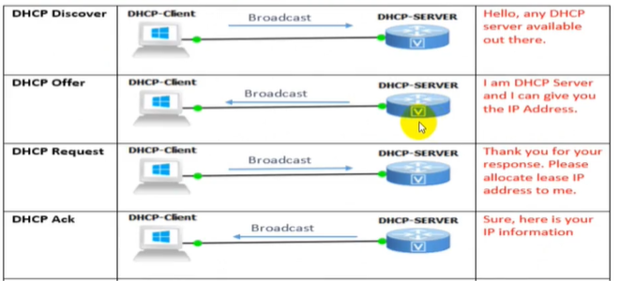

**Configure DHCP**

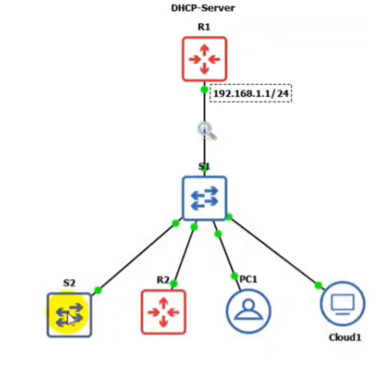

R1(config)#[assign ip to internal interface e0/0 192.168.1.1/24]

R1(config)#ip dhcp exclude-address 192.168.1.1 192.168.1.100 [do not assign to any client ip from this range]

R1(config)#ip dhcp pool abc

R1(dhcp-config)#network 192.168.1.0 /24 [here dhcp became R1]

R1(dhcp-config)#dns-server 8.8.8.8 8.8.2.2 2.2.2.2 [here 3 dns servers are assigned if one is down another will be used]

R1(dhcp-config)#domain-name test.com

R1(dhcp-config)#default-router 192.168.1.1

R1#show running-config | sec dhcp

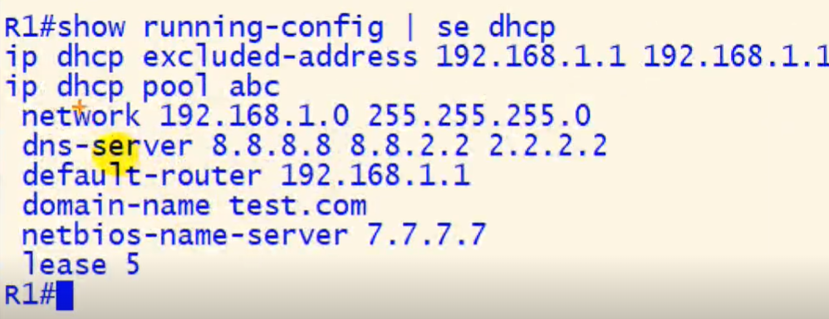

**Client Receiving IP:**

R2(config)#inter f0/0

R2(config-if)#ip address dhcp

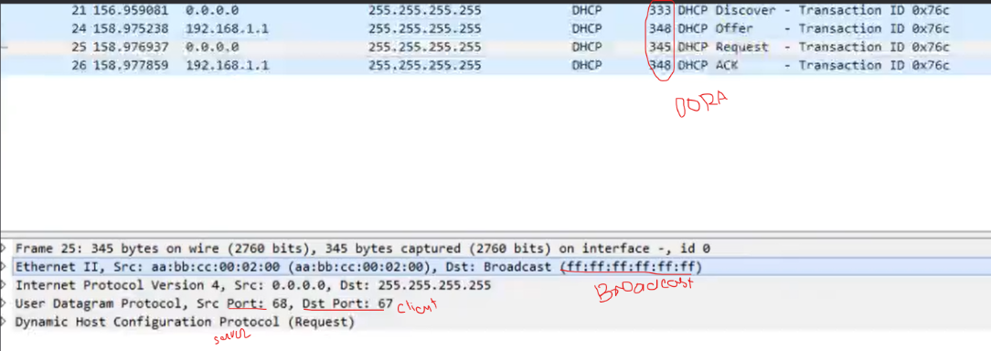

**Configure DHCP Using Relay:**

